Enjoy few Simple Recipes
Using Girl Scout Cookies

*************************************************************************************

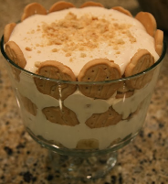
Girl Scout Banana Pudding
2 boxes Shortbread Girl Scout Cookies
4-5 large bananas, sliced
1 large container cool whip
1 large box instant vanilla pudding
1 can condensed milk

First, make the pudding as directed. Let the pudding sit for a couple of minutes while you slice up the bananas. Add the condensed milk to the pudding and mix it for a couple of minutes more. Fold in Cool Whip. Break up some cookies and place them in the bottom of a trifle dish. Add a layer of bananas and then cover it with the creamy pudding mixture. Add a layer of cookies on top. Alternate those layers (cookies, bananas, pudding) to the top. Sprinkle more crumbs on top.

A good way to enjoy this yummy springtime treat…
Girl Scout Cookies freeze well, so if you have enough self-control,
put a couple of boxes of the cookies in the freezer and save for later.
Happy Eating!

*************************************************************************************

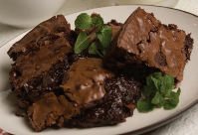
Girl Scout Thin Mint Brownies

½ box of crushed Girl Scout Thin Mint Cookies
1 box brownie mix
2 eggs (3 eggs for cake-like brownies)
¼ cup of water
½ cup of vegetable oil

Crush Thin Mints into medium size chunks. Mix all ingredients into mixing bowl. Do not use electric mixer — batter will be stiff. Spread batter evenly in greased baking pan (13 x 9 x 2 inch). Bake in center of oven at 350 degrees for 30 to 35 minutes. Allow to cool before cutting.

A good way to enjoy these all year long…
Girl Scout Cookies freeze well, so if you have enough self-control,
put a couple of boxes of the cookies in the freezer and save for later.
Happy Eating!

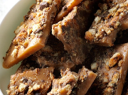
Caramel deLites Toffee

2 boxes Girl Scout Caramel deLites cookies
2 cups butter
2 cups sugar
1 dash salt

Pulse two boxes of cookies in a food processor until crumbled.
Sprinkle one-third on a baking sheet lines with foil.
In a large saucepan over medium heat, cook butter, sugar and salt, stirring frequently, until mixture reaches 300 degrees. Remove, carefully pour over crumbled cookies, spreading with a spatula to cover. Top with remaining crumbled cookies, pressing down slightly. Refrigerate at least 2 hours. When cool, break into pieces.

A good way to enjoy these all year long…
Girl Scout Cookies freeze well, so if you have enough self-control,
put a couple of boxes of the cookies in the freezer and save for later.
Happy Eating!

*************************************************************************************

Girl Scout Peanut Butter Sandwich
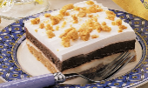
Yum Yum Cake

2 ¼ cups crushed PB Sandwich GS Cookies
¼ cup sugar
¼ cup butter, melted
2 pkg 3 oz. cream cheese, soft
1 cup confectioners’ sugar
1 carton 8 oz frozen whipped topping, thawed, divided
2 ½ cups cold 2% mild
2 pkgs instant chocolate pudding
Additional PB cookies, broken into pieces

In a large bowl, combine crushed cookies, sugar and butter; press into an ungreased 12 x 9 baking pan. Bake at 350 for 6 – 8 minutes or until golden brown; cool on a wire rack.

In a large bowl, beat cream cheese and confectioners’ sugar until smooth;
fold in 1 cup whipped topping. Spread over cooled crust.

In another large bowl, beat milk and pudding mix on low speed for 2 minutes or until thickened. Spread over cream cheese layer. Top with remaining whipped topping; sprinkle with cookie pieces. Cover and refrigerate for at least 1 hour before serving.

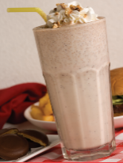
Girl Scout Peanut Butter Patties
Milkshake

1/2 box of Tagalongs Girl Scout Cookies
6 cups of vanilla ice cream
1 cup of milk
1 can of whipped cream

Mix cookies, ice cream and milk in blender. Blend until desired thickness.
Serve in tall milkshake glass and top with whipped cream and
garnish with crumbled cookies.

A good way to enjoy this yummy springtime treat…
Girl Scout Cookies freeze well, so if you have enough self-control,
put a couple of boxes of the cookies in the freezer and save for later.
Happy Sipping!

******************************************************************************************

Girl Scout Lemonade
Shortbread Cheesecake
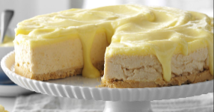
1 pkg Shortbread Cookies
¼ cup butter, melted
2 pkgs Girl Scout Lemonades Cookies
1 pkg cream cheese, softened
½ cup sugar
1 tsp vanilla extract
1 ½ cups heavy whipping cream
3 eggs
1 cup sugar
1 cup lemon juice
½ cup butter, cubed

Place Shortbread cookies in food processor; pulse until fine crumbs form.
Add butter; pulse just until blended. Press onto bottom of greased 9 inch springform pan.
Freeze 10 minutes.

Place Lemonade cookies in a clean food processor; pulse until fine crumbs form. In a large bowl, beat cream cheese, sugar and vanilla until smooth. Gradually beat in Lemonade crumbs.

In another bowl, beat whipping cream until soft peaks form; fold into cream cheese mixture.
Spread over crust. Freeze, covered for 1 hour.

Meanwhile, in a small heavy saucepan, whisk eggs, sugar and lemon juice until blended. Add butter; cook over medium heat, whisking constantly until mixture is just thick enough to coat a metal spoon and a thermometer reads at least 170. Do not allow to boil. Remove from heat immediately. Strain through a fine-mesh strainer into a small bowl; cool. Press plastic wrap onto surface of lemon curd. Refrigerate until cold.

Spoon 1 cup lemon curd over cheesecake. Freeze 1 hour longer.
Remove rim from pan. Serve with remaining lemon curd.

